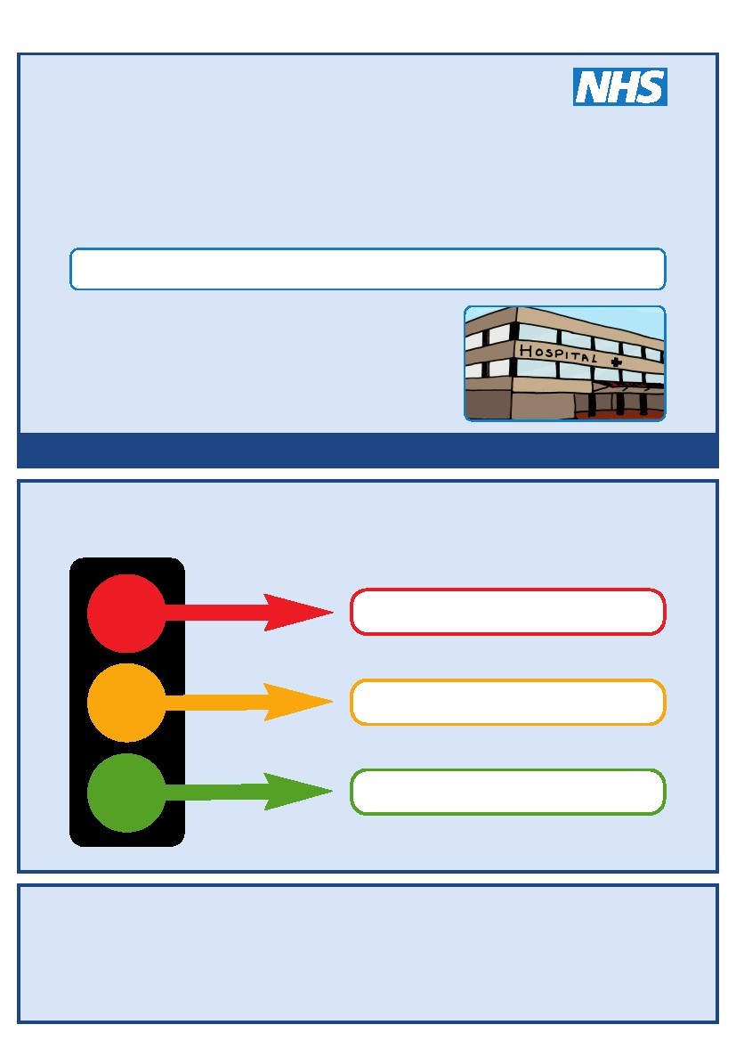
This is my
Hospital Passport
For people with learning disabilities coming into hospital
If I have to go to hospital this book needs to
go with me, it gives hospital staff important
information about me.
It needs to hang on the end of my bed and a
copy should be put in my notes.
This passport belongs to me. Please return it when I am discharged.
Nursing and medical staff please look at my passport
before you do any interventions with me.
Things you must know about me
Things that are important to me
My likes and dislikes
Epsom and St Helier University Hospitals NHS Trust
Kingston Hospital NHS Trust
Mayday Healthcare NHS Trust
St George’s Healthcare NHS Trust
Foundation of Nursing Studies
Croydon Community Learning Disability Team
Kingston Community Learning Disability Team
Merton Team for People with Learning Disabilities
Richmond Specialist Healthcare Team (Learning Disabilities)
Sutton Learning Disabilities Team
Wandsworth Community Learning Disability Team
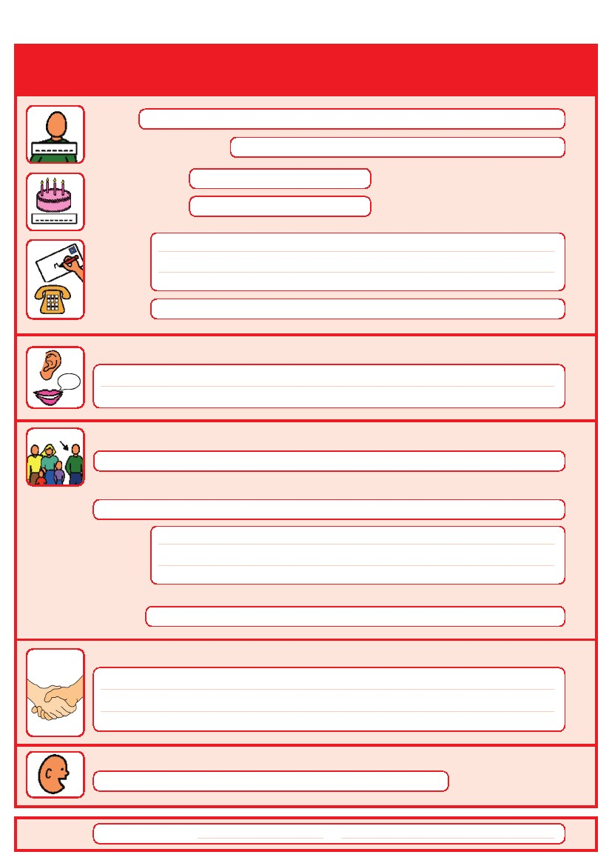
Things you must know about me
Name
Likes to be known as:
NHS number:
Date of Birth:
Address:
Tel No:
Family contact person, carer or other support:
How I communicate/ what language I speak:

Relationship e.g. Mum, Dad, Home Manager, Support Worker:

Address:

Tel No:
My support needs and who gives me the most support:
My carer speaks:

Date completed:
1
By:
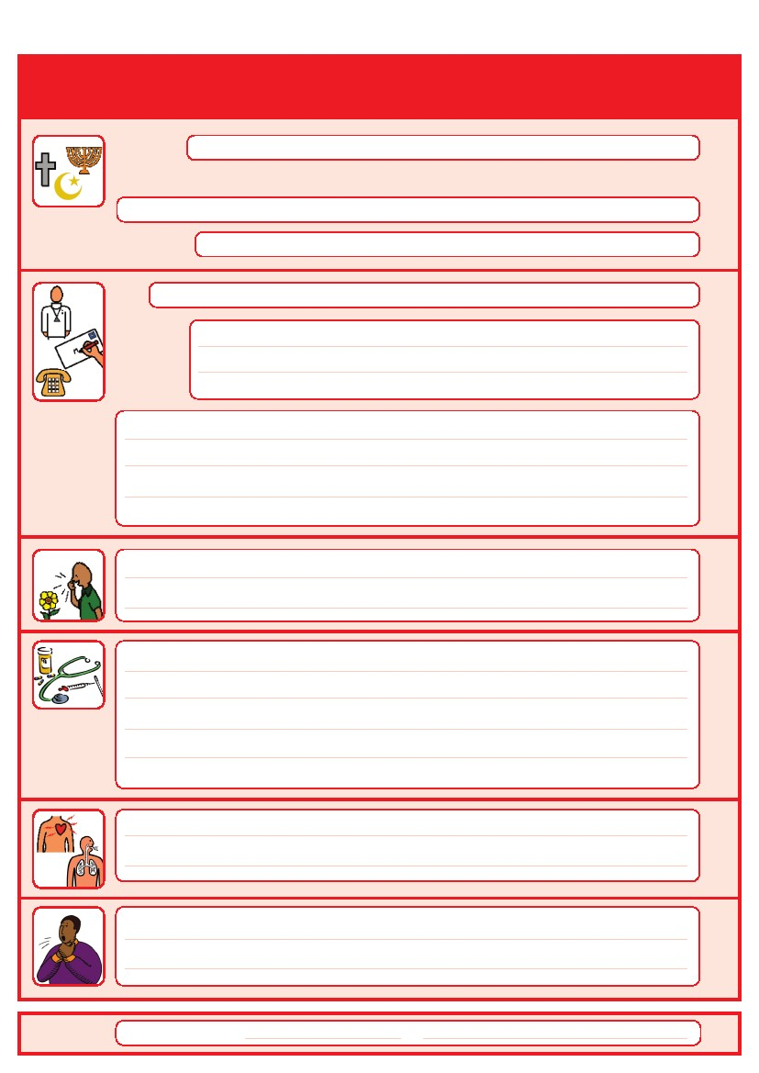
Things you must know about me
Religion:
Religious/Spiritual needs:

Ethnicity:
Address:
GP:
Tel No:
Other services/professionals involved with me:

Allergies:

Medical Interventions – how to take my blood, give injections, BP etc.

Heart
Breathing problems
Date completed:
Risk of choking, Dysphagia (eating, drinking and swallowing):

2
By:
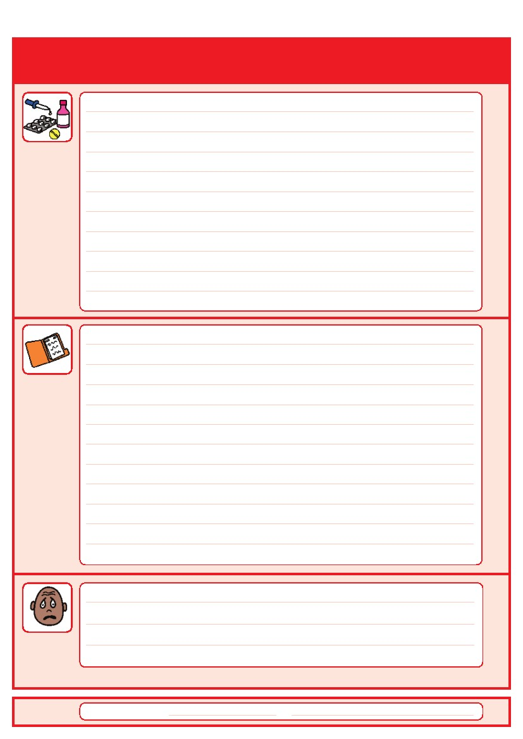
Things you must know about me
Current medication:

My medical history and treatment plan:

Date completed:
What to do if I am anxious:
3
By:
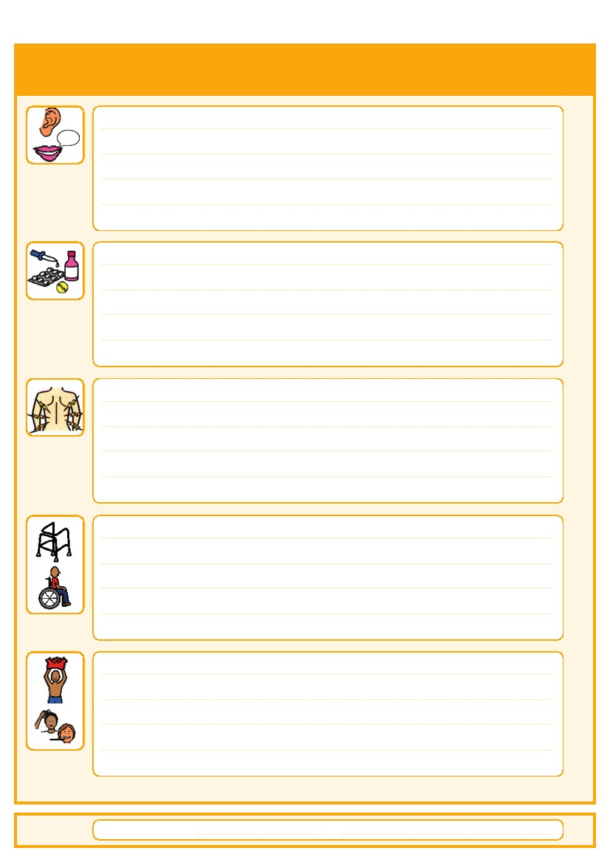
Things that are important to me
4
How to communicate with me:

How I take medication: (whole tablets, crushed tablets, injections, syrup)

How you know I am in pain:

Moving around: (Posture in bed, walking aids)

Personal care: (Dressing, washing, etc)

Date completed:
By:
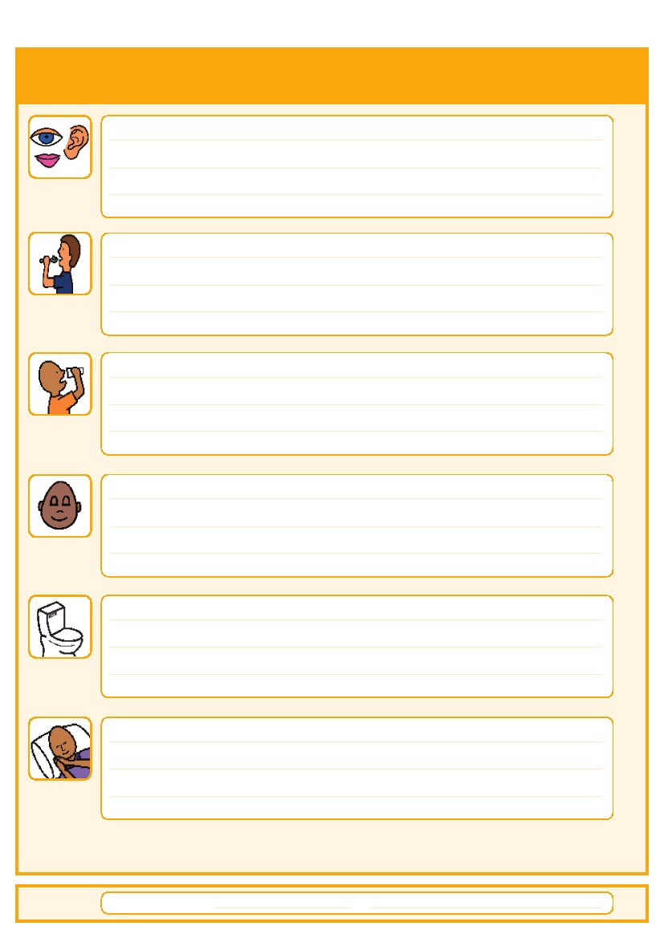
Things that are important to me
Date completed:
Seeing/Hearing: (Problems with sight or hearing)

How I eat: (Food cut up, pureed, risk of choking, help with eating)

How I drink: (Drink small amounts, thickened fluids)

How I keep safe: (Bed rails, support with challenging behaviour)

How I use the toilet: (Continence aids, help to get to toilet)

Sleeping: (Sleep pattern/routine)

5
By:
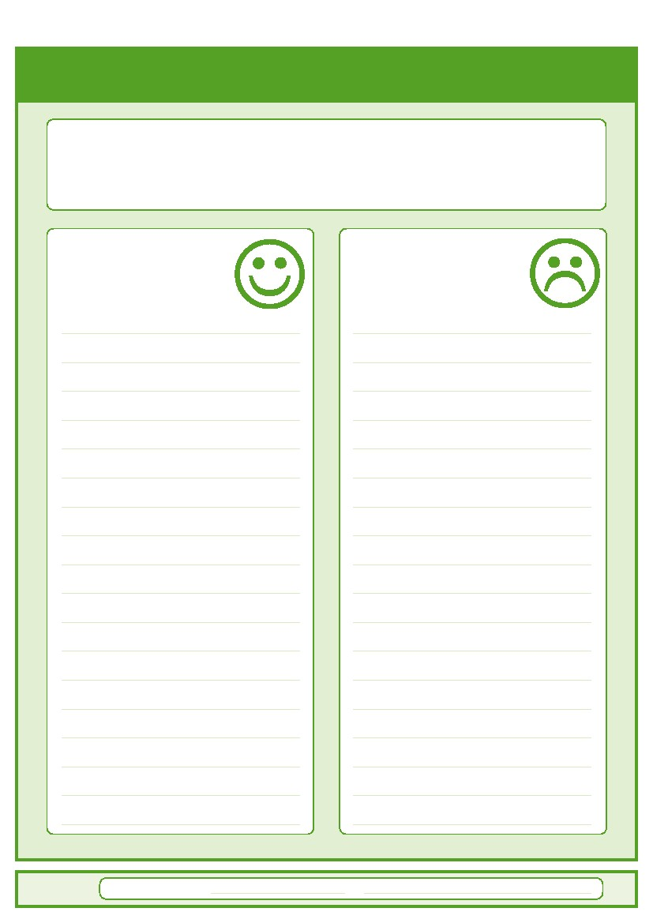
My likes and dislikes
Likes:
Dislikes:.
7
Things I like
Please do this:

Things I don’t like
Don’t do this:

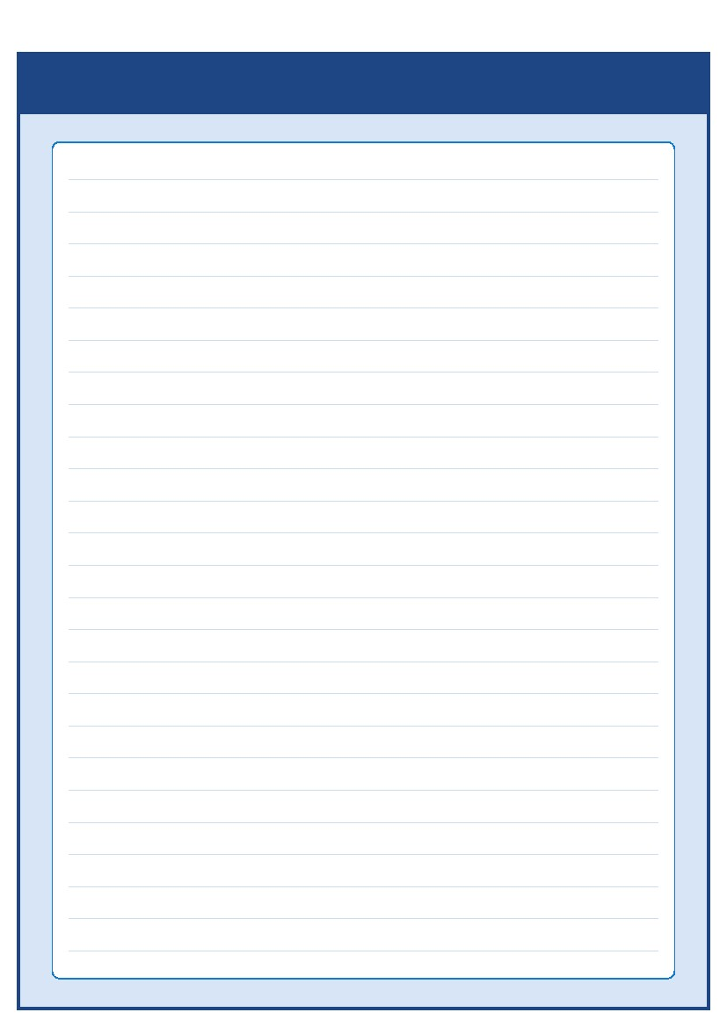

Durants School,
020 8804 1980

Dr Witchanachchi, Paediatrician, Chase Farm Hospital
020 87023458

Cheviots Children’s Disability Services
020 8363 4047

SCAN – Service for Children & Adolescents with Neurodevelopmental disorders
020 8702 5160

Community Mental Health Teams, Chase Farm Hospital
020 8702 5000

Nutrition & Dietetic Service
020 8702 5660

Crisis Resolution and Home Treatment Team (CRHT) Service
020 8702 3800

Enfield Therapy Service
020 8702 5011
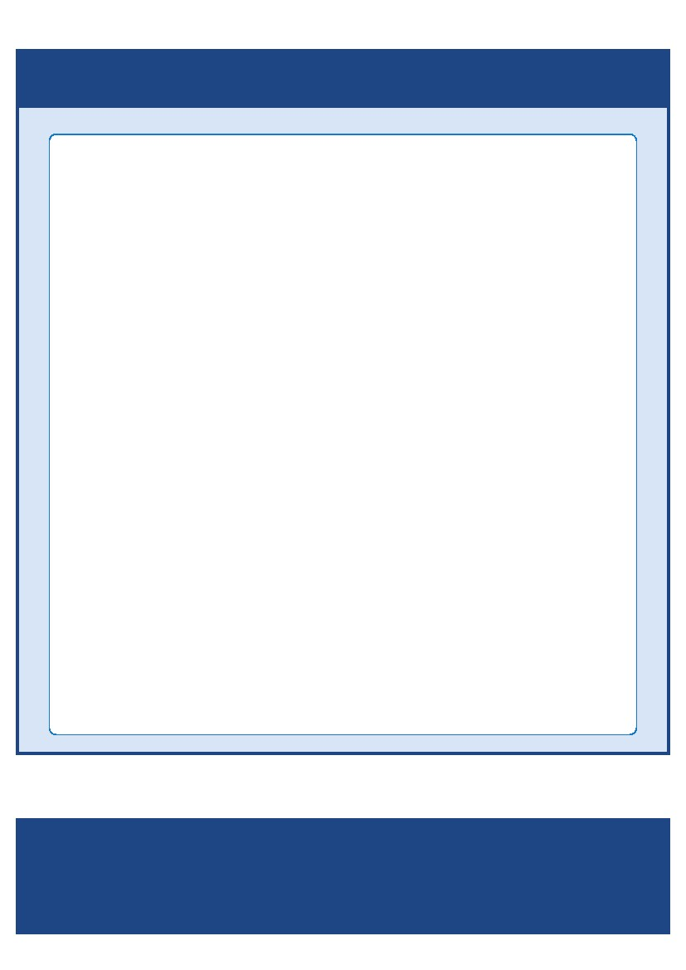Contacts a
nd useful websites
Key Contacts:

Please contact your local community learning disability team

Adults Information

Integrated Learning Disability Service (ILDS – Adult Team)
St. Andrew’s Court, 1-4 River Front, Enfield. EN1 3SY

ILDS - Main Switchboard
0208 379 5039

Community Mental Health Teams
Chase Farm Hospital
0208 702 5000

Adult Social Care
14 Centre Way, London N9 0AH
0208 379 1001

Nutrition + Dietetic Service
Community Therapies Office, Pine Lodge, St Michael’s Site, Gater Drive, Enfield EN2 OJB
0208 702 5660

Crisis Resolution and Home Treatment Team (CRHT) Service
Ivy House, Chase Farm Hospital, Enfield

0208 702 3800

Enfield Therapy Service
The Chase Building, Chase Farm Hospital, The Ridgeway, Enfield, EN2 8JL
0208 702 5011
nd useful websites
if you have any questions about the passport
AS.42a (12.09)

