Print and cut out the symbols and stick them in the correct place on the worksheet. You can stick the symbol or write down the answer. Try answering the questions independently. You can try choosing from the choice of two symbols.
From the picture say if this is water or ice, and say if it is a solid or a liquid.

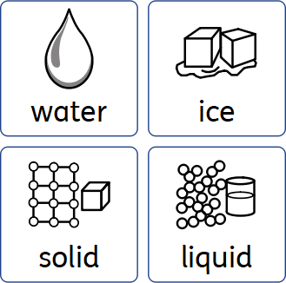
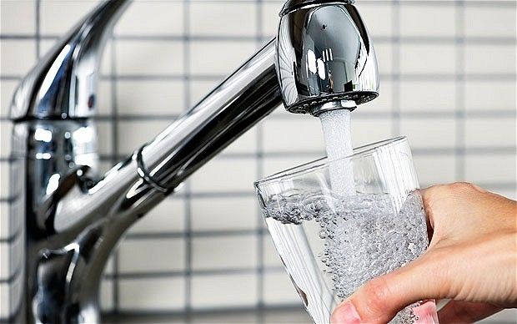
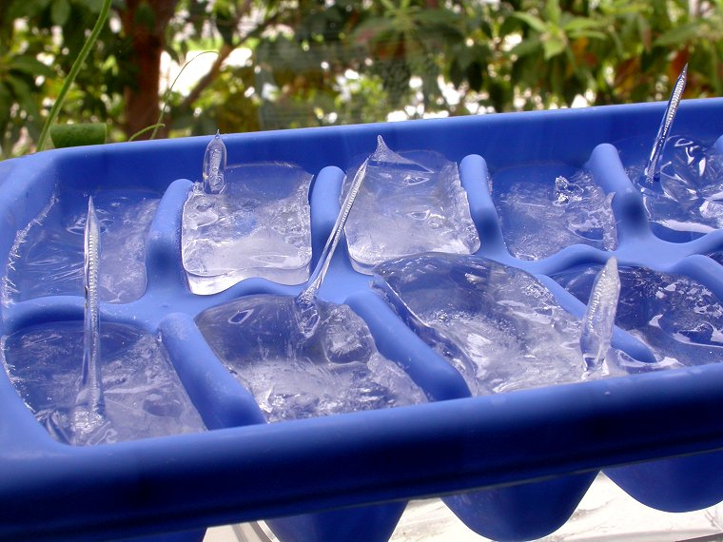
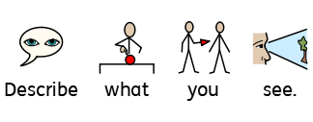
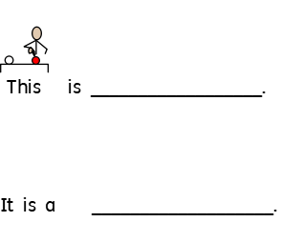
 | 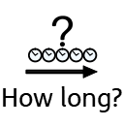
RECORDING SHEET
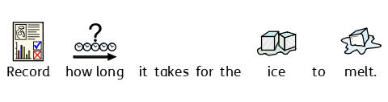

Before the experiment

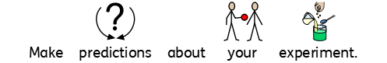

I think the ice in/on ________________________ will melt first.

I think the ice in/on ________________________ will melt last.

After the experiment

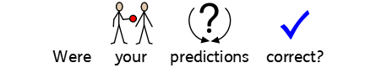

The ice in/on _____________________________ melted first.

The ice in/on _____________________________ melted last.

RECORDING SHEET


